**An**

**INTERNSHIP REPORT**

**On**

**“Front End Development”**

Submitted to the faculty of

**Computer Science & Engineering,**

**Tatyasaheb Kore Institute of Engineering & Technology**

In partial fulfillment of the requirements for the Award of Degree of

**B.Tech.**

**In**

**Computer Science & Engineering**



Submitted By

Mr. Saurabh Sanjay Patil.

**DEPARTMENT OF COMPUTER SCIENCE & ENGINEERING**

**TATYASAHEB KORE INSTITUTE OF ENGINEERING AND TECHNOLOGY, WARANANAGAR.**

**Academic Year 2022 - 2023**

**TATYASAHEB KORE INSTITUTE OF ENGINEERING AND TECHNOLOGY, WARANANAGAR**

**DEPARTMENT OF COMPUTER SCIENCE ENGINEERING**



**CERTIFICATE**

This is to certify that **Mr.Saurabh Sanjay Patil. (Roll No: 154, Class/Division: B)** has successfully completed Internship Course on “**Web Development**” in “**Comtranse Technology Pvt.Ltd, Kolhapur”** as partial fulfillment of the requirement for B.Tech. (Computer Science & Engineering) Semester-VII of Shivaji University, Kolhapur during the period from 29th Aug 2022 to 29th Oct 2022 in Academic year 2022-23.

**Faculty Mentor/Supervisor Internship Coordinator**

**Head**

**Department of CSE PRINCIPAL**

**Date:**

**Place: Warananagar**

**DECLARATION**

To,

HOD,

Department of Computer Science & Engineering,

TKIET, Kolhapur.

Respected sir,

I undersigned here declare that the project module on “**Website Development”** is developed by me in “**Comtranse Technology Pvt.Ltd, Kolhapur”**. I am declaring that this is my original work. I have not copied any material, which are useful to work or other reports that are submitted to the **“Department of Computer Science and Engineering, Tatyasaheb Kore Institute of Engineering and Technology, Warananagar”**. I am ready to face the consequences in way, college authorities may deem fit, if above matter proved to be false.

Yours faithfully,  **Saurabh Sanjay Patil.**

**ACKNOWLEDGEMENT**

I take pleasure in presenting my internship work done in “**Comtranse Technology”** during the last **Sixty days**. The internship period was an enriching experience for me from professional as well as personal front getting an opportunity to familiarize myself to the IT industry.

First, I would like to thank **Mrs. Trupti Gaikwad** of “**Comtranse Technology”** for having faith in me and giving me the opportunity to work in their organization.

I wish to express my thanks to all in the company who have helped and guided me during this period. I would like to express my gratitude to HOD **Prof. R.B. Patil**, Internship Coordinator **Prof. K.N. Kamble**, Faculty Mentor/Supervisor **Prof. S.A. Urbhinhatti.** and entire Computer Science & Engineering department of Tatyasaheb Kore Institute of Engineering and Technology, Warananagar for their valuable guidance and support. I would also like to express my gratitude towards my colleagues and friends for the moral and technical support throughout the duration of my project.

Finally, this acknowledgement would be incomplete without rendering my sincere gratitude to all those who have helped me in the completion of presentation.

Sincerely,

**Saurabh Sanjay Patil.**

**INDEX**

|  |  |  |
| --- | --- | --- |
| **Sr.No.** | **Content** | **Page No.** |
| 1. | Introduction | 1-1 |
|  | * 1. Organization Overview | 1-1 |
|  | * 1. Project Overview | 1-1 |
| 2. | Requirement analysis | 2-3 |
|  | * 1. Data Requirement | 2-2 |
|  | * 1. Functional Requirements | 2-2 |
|  | * 1. Non-Functional Requirements | 3-3 |
|  | * 1. System Requirements (Hardware and Software) | 3-3 |
| 3. | Software system Attributes (Technologies and Frameworks used) | 4-4 |
| 4. | System Design | 5-5 |
| 5. | Coding | 6-16 |
| 6. | Graphical User Interface (GUI) Snapshots | 17-18 |
| 7. | Conclusion | 19-19 |
| 8. | Bibliographies | 19-19 |
| 9. | **Appendix** |  |
|  | 1. **Student internship program application** |  |
|  | 1. **Request letter from institute to internship provider** |  |
|  | 1. **Student Daily Diary (Log) Recordings** |  |
|  | 1. **Supervisor Evaluation of Intern** |  |
|  | 1. **Student Feedback of Internship** |  |

**1. Introduction**

**1.1 Organization Overview**

* + - **Name of Industry: Comtranse Technology Pvt. Ltd, Kolhapur.**
    - **Industry Introduction:**

The company was incorporated in the year 2011 in Maharashtra. The main reason of set-up is to provide the best industry level services locally. The name ‘COMTRANSE' is fusion of Computing, Transaction and Services. Their mission is to enhancing the business growth of our customers with creative Design and Development. Our vision is to develop in a constant manner and grow as a major IT service provider of quality Web and Software Development solutions in the competitive global marketplace. We are committed to deliver best industry practices coupled with emerging practical and dependable technological solutions.

* + - Products and Services:

### **Consulting: -**

1. ERP Consulting.
2. Automation of Business Process.
3. Work Flow Management.
4. ISO standard implementation.
5. E-commerce solutions.

### **Technical: -**

1. Technical Solution.
2. Data Migration.
3. DBA Support.

### **IS Security: -**

1. IT Policy.
2. IT Governance.
3. IS Auditing.
   1. **Project Overview**

A company website is a great way to reach more customers and get more cliets. Company websites also helps in building the brand. It lets people find you online. People look online for company details such as phone number, address, reservation details and opening times. Also to share details directly to client like technical details, projects completed and clients reviews. So we decide to design a restaurant website with the help of some web designing techniques like HTML, CSS, and Bootstrap. It is an dynamic website in which we provide some tab like Home, About, Event, Menu and Contact. With the help of this website you can book your order for different functions.

1. **Requirement analysis**
   1. **Functional Requirements:**

There are functions done by the system such as; store the necessary information of machines, prepare bill for the orders, give week reports, add new products, taking orders and shipping the orders. Also it stores information about staff.

* Admin has access to monitor everything in the online machinery shop.
* Admin can add, update all the orders of the online machinery shop.
* The customer can view machinery shop items and then finally add machines to the shopping cart and order the same.
* The customer has to fill form providing his/her name, number, address, city delivery times slot and payment method (cash on delivery) after he\she check out from the shopping cart.
* Machinery items will be delivered to the customer at home with respect to the selected time slot.

**2.2 Non-Functional Requirements:**

* 1.Scalability: The software should be portable. So, moving from one browser to other browser does not create any problem
* 2.Reliability: The web app must be reliable. No user should be able to access the other user’s data.
* 3.Performance: System must be able to handle as many users as possible at the time
* 4.Maintainability: System should be easy to maintain.
* 5.Usability: System must be easy to use for any user

.

**2.3 System Requirements (Hardware and Software)**

* Hardware Requirement

Processor : Pentium 4 and above (Minimum 1.66 GHz.)

Memory : 2GB or Higher.

Hard Disk : 50GB or Higher Minimum 350MB Hard Disk space for installation.

* Software Requirement

Operating System : Windows 7 or above versions. Front End : HTML, CSS, Bootstrap



Editor : Sublime Text 3

**3. Software system Attributes (Technologies and Frameworks used)**

Various tools and technology were used during our internship

training.

Some of them are listed below:

1. HTML5

HTML stands for Hyper Text Mark-up Language. It is

used to design web pages using mark-up language. HTML

is the combination of Hypertext and Mark-up language.

Hypertext defines the link between the web pages. Mark-

up language is used to define the text document within tag

which defines the structure of web pages. HTML5 is the

fifth and current version of HTML. It has improved the

mark-up available for documents and has introduced

application programming interfaces (API) and Document

Object Model (DOM).

Various tools and technology were used during our internship

training.

Some of them are listed below:

1. HTML5

HTML stands for Hyper Text Mark-up Language. It is

used to design web pages using mark-up language. HTML

is the combination of Hypertext and Mark-up language.

Hypertext defines the link between the web pages. Mark-

up language is used to define the text document within tag

which defines the structure of web pages. HTML5 is the

fifth and current version of HTML. It has improved the

mark-up available for documents and has introduced

application programming interfaces (API) and Document

Object Model (DOM).

Various tools and technology were used during our internship training. Some of them are listed below:

* **HTML:**

HTML is a markup language that defines the structure of your content.HTML consists of series of elements, which you use to enclose, or wrap, different parts of the content to make it appear a certain way, or act a certain way. The enclosing tags can make a word or image hyperlink to somewhere else, can italicize words, can make font bigger or smaller, and so on.

* **CSS:**

CSS stands for Cascading Style Sheets.CSS describes how HTML elements are to be displayed on screen, paper, or in other media.CSS saves a lot of work. It can control the layout of multiple web pages all at once. External style sheets are stored in CSS files, it is used to style and layout web-pages. For example, to alter the font, colour size and spacing of your contents, split it into multiple columns, or add animations and other decorative features.

* **BOOTSTRAP:**

Bootstrap is a free, open source front-end development framework for the creation of a websites and web-apps. Designed to enable responsive development of mobile-first websites, Bootstrap provides a collection of a syntax for a template designs. As a framework, bootstrap includes the basics for responsive web development, so developers only need to insert the code into a predefined grid system. The bootstrap framework is built on HTML, CSS and Java-script.

**4. System Design**

**4.1 Component Diagram**

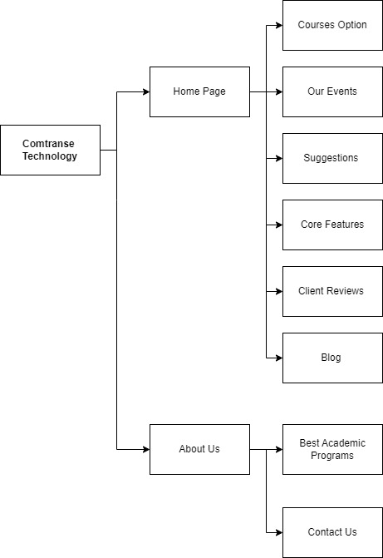

**Graphical User Interface (GUI) Snapshot:**

**5.1 Landing Page(Comtranse Technology)**

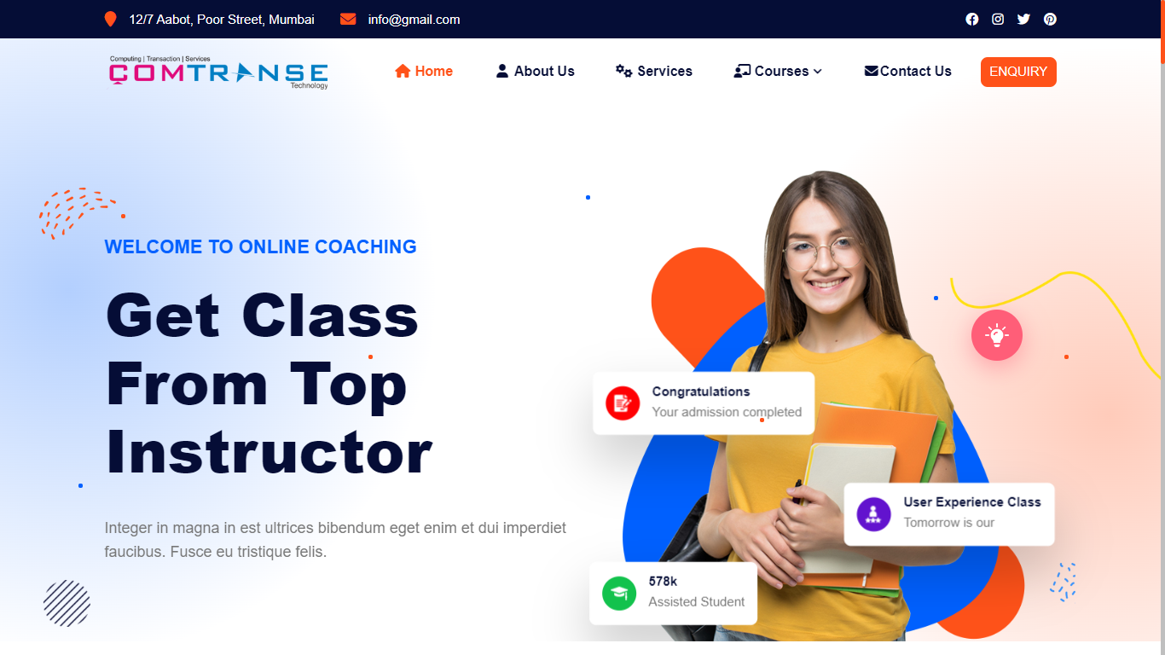

**5.2 Our Events :**

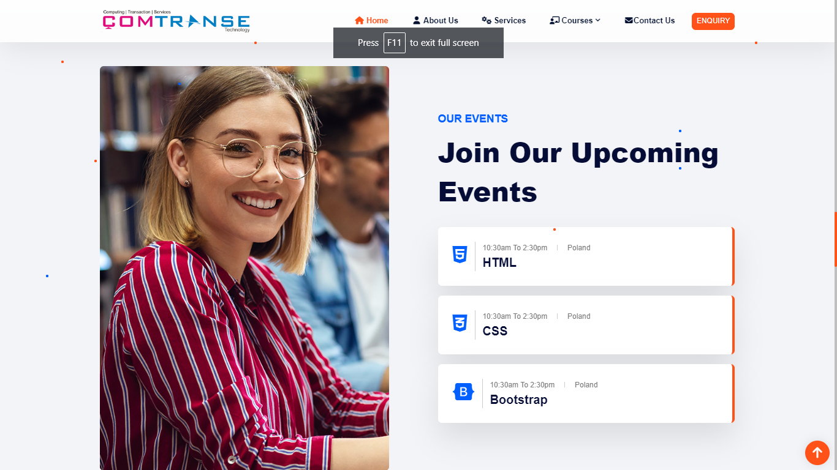

* 1. **Our Online Courses:**

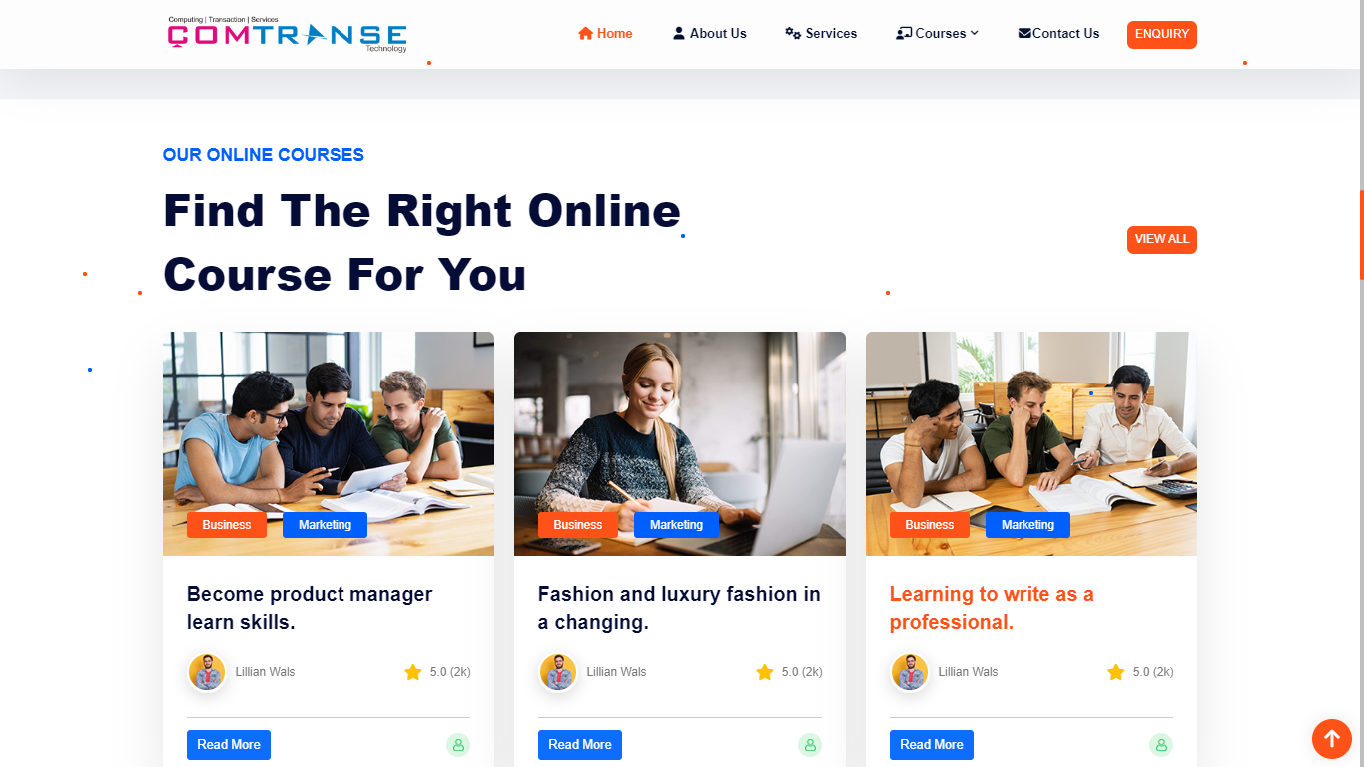

* 1. **Core Features :**

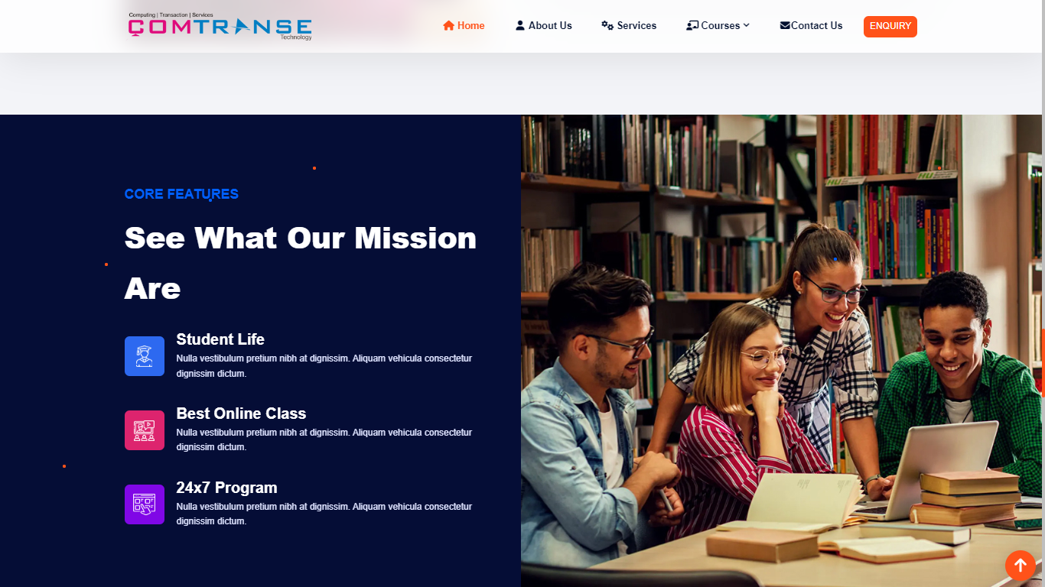

* 1. **Best Resources :**

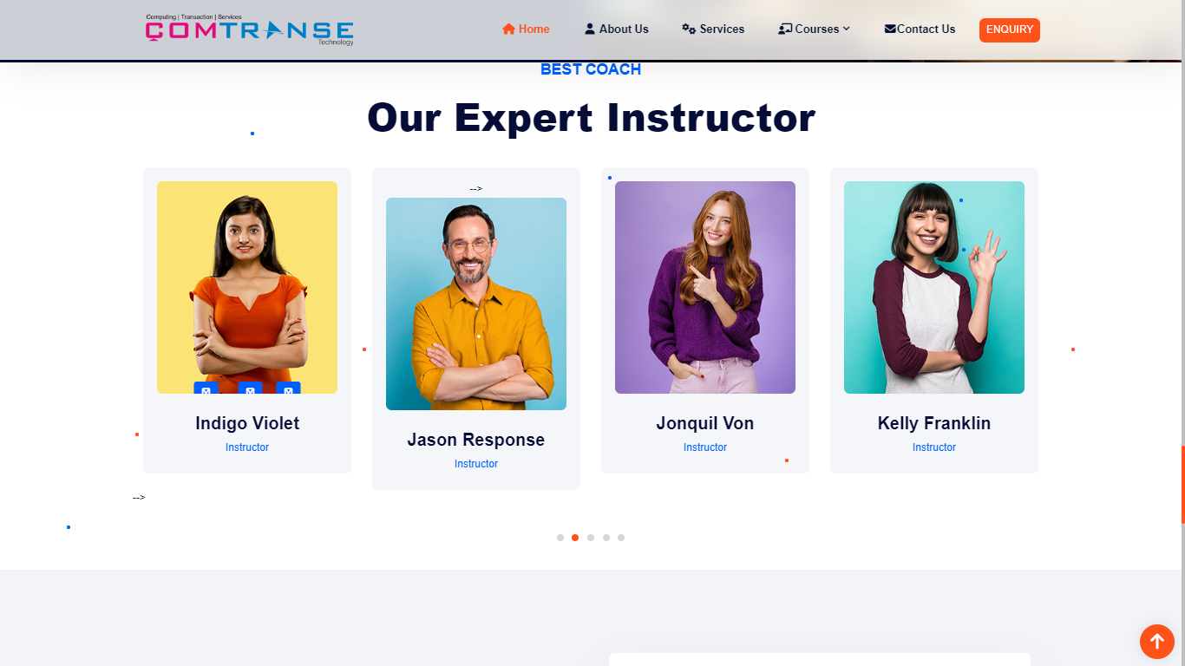

* 1. **Clients and Blogs :**

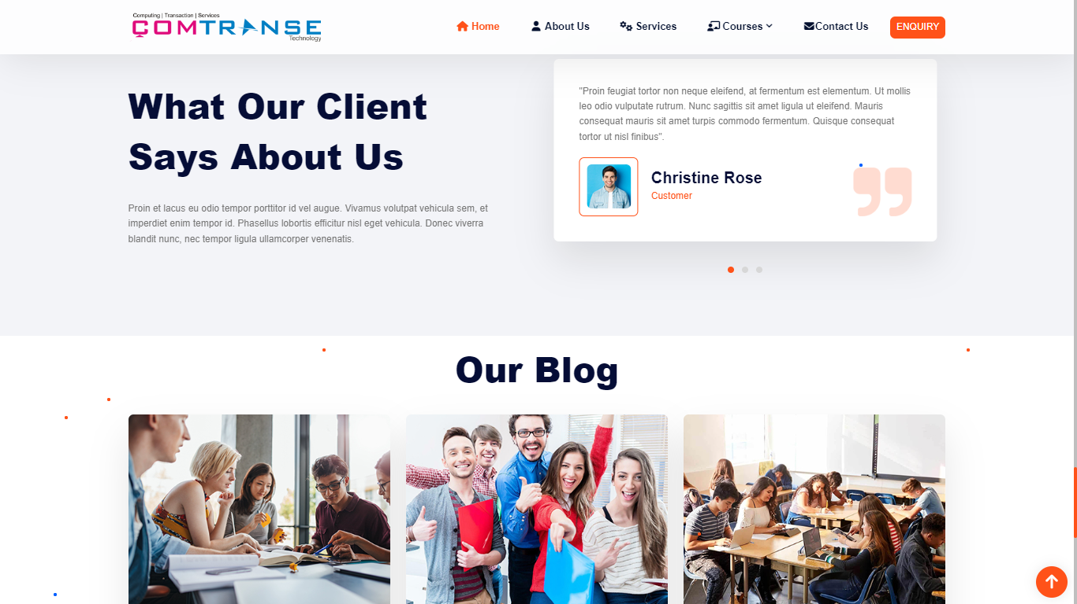

**6. Conclusion:**

During the internship I have learned about frontend web development and how they actually we can design the website as industry level. Using HTML, CSS and Bootstrap with these we developed a simple website in short time. In this internship program we learned about how bootstrap make website designing is that much simple.

I learned to live in a different environment from the one I am

used to. Indeed, I grew more independent in work and also in

everyday life. I realized that I could do more things than I

thought, like learning new things by myself.

I learned to live in a different environment from the one I am used to. Indeed, I grew more independent in work and also in everyday life. I realized that I could do more things than I thought, like learning new things by myself.

**7. Bibliographies**

-http://www.w3schools.com

-http://www.wikipidea.com

-http://www.w3.org/standards/semanticweb/

-http://developer.mozilla.org/en/docs

-http://sioc-project.org/ontology

-http://janastu.org

* -http://www.w3schools.com
* -http://www.wikipidea.com
* <http://www.codeproject.com/php>



* <http://www.Tutorialspoint.com/>

Cascading Style Sheets, fondly referred to as CSS, is a

simply designed language intended to simplify the

process of making web pages presentable. CSS allows

you to apply styles to web pages. More importantly, CSS

enables you to do this independent of the HTML that

makes up each web pa

Cascading Style Sheets, fondly referred to as CSS, is a

simply designed language intended to simplify the

process of making web pages presentable. CSS allows

you to apply styles to web pages. More importantly, CSS

enables you to do this independent of the HTML that

makes up each web pag

Cascading Style Sheets, fondly referred to as CSS, is a

simply designed language intended to simplify the

process of making web pages presentable. CSS allows

you to apply styles to web pages. More importantly, CSS

enables you to do this independent of the HTML that

makes up each web pag

Various tools and technology were used during our internship

training.

Some of them are listed below:

1. HTML5

HTML stands for Hyper Text Mark-up Language. It is

used to design web pages using mark-up language. HTML

is the combination of Hypertext and Mark-up language.

Hypertext defines the link between the web pages. Mark-

up language is used to define the text document within tag

which defines the structure of web pages. HTML5 is the

fifth and current version of HTML. It has improved the

mark-up available for documents and has introduced

application programming interfaces (API) and Document

Object Model (DOM).

Below example illustrate the HTML5 content:

<!DOCTYPE html>

<html>

<head>

<title>Page Title</title>

</head>

<body>

<h1>This is a Heading</h1>

<p> This is a paragraph. </p>

</body>

</html